Reservoir
Speech and Debate Team

Speech Debate Dramatic Performance
Official Website

Reservoir Speech and Debate Club is an extracurricular activity where students at RHS can compete in Debate, Speech, and Drama and build lifelong skills in public speaking, writing, and researching.
Last year we made it to states with one student qualifying for nationals, and we intend to continue that success into the 2010-2011 year!
Why should I join speech and debate?

Contents:

Information
Competition Events
- Speech
- Debate
- Dramatic Performance
Dates
Links to important sites
Contact US
Photo gallery
Last Updated

Information

Reservoir Speech and Debate Club will be meeting on Tuesdays starting next year and will be organizing several fundraisers.
Thanks to Mrs. Mariner for leading our club during the 2009-2010 year and to Mrs. Mandile who has volunteered to be our new coach. Also, thank you to Alyson for coaching us in Lincoln-Douglass debate and seeing us to the state level.

Competition Events

You can compete in any or more of the following events and you may select more than one to compete in:

Speech
  - Original Oratory- Students prepare original orations, usually persuasive or informative on a current topic. Any topic is permissible and any form of oration is permitted. The presentation must be memorized, with a maximum length of ten minutes. (Information PDF)
  - Oratorical Declamation- Open to students in the ninth or tenth grades only. Students must use a speech or portion of a speech previously given by another person. The speech must be memorized with a maximum length of ten minutes. (Information PDF)
  - Extemporaneous Speaking- Each student draws three topics on current issues; chooses one and has thirty minutes to prepare a speech of a maximum length of seven minutes. Any periodical or other published material is permitted in the preparation room. Students may not refer to any written notes during the speech. (Information PDF)
  - Oral Interpretation of Literature (Poetry and Prose)- Students present selections in two categories -- prose and poetry. Each selection must be a maximum of ten minutes. The student must hold a manuscript and appear to be reading. The students alternate between rounds of prose and rounds of poetry. (Information PDF)

Debate
  - Lincoln-Douglas Debate- Individual students debating issues of values and philosophy. (Sample Arguments)
  - Public Forum- A team event that advocates or rejects a position posed by the resolution. The debate is a clash of ideas given in a persuasive manner that can be understood by a “lay” judge. Good debaters should display logic and analysis. They should use evidence when needed, they should win their case and refute that of their opponents, and they should communicate effectively. There are no burdens on either side. (Information PDF)
  - Policy Debate- Two person teams debating issues of policy. Students should display logical analysis supported by evidence. (Information)
  - Student Congress (Congressionals)- Permits students to participate in parliamentary debate. Legislation is prepared by the students in advance in the areas of Domestic, Economic, and Foreign Affairs. Students debate the merits of the legislation presented. (Information)

Dramatic Performance
  - Dramatic Performance- present selections from published plays, screenplays, fictional or non-fictional works that are either serious or humorous in nature. The selections must be memorized with a maximum length of ten minutes. (Information PDF)
  - Duo Interpretation of Literature- A presentation by two participants of a single selection of literature. Each performer may present one or more characters and each character should be sufficiently developed and should interact meaningfully with the other characters. The sections must be memorized. Movement should be limited. The maximum length is ten minutes. (Information PDF)
  - Children’s Literature- Perform children’s books, such as Pirates of the Caribbean or Dr. Seuss.
  - Humorous Interpretation- (only for NFL) this is an individual category in which the selections are humorous in nature. All other rules are the same as Dramatic Interpretation.
(Go to top)

Dates

Please see our schedule on our website under the Schedule Tab.

Important Links

National Catholic Forensic League (NCFL): http://www.ncfl.org/index.html
Baltimore Catholic Forensic League (BCFL): http://bcfl.net/
Reservoir High School (RHS): http://rhsgators.com/

Contact us
Contact us by going to RHS Gators Staff Directory Mrs. Mandile (Under Administration…) OR by coming to our meetings.

(Go to top)

Photo Gallery

2009-2010:
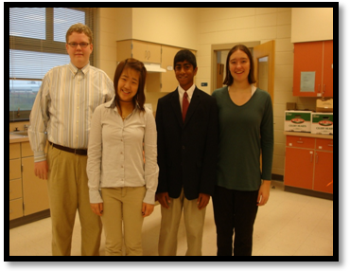
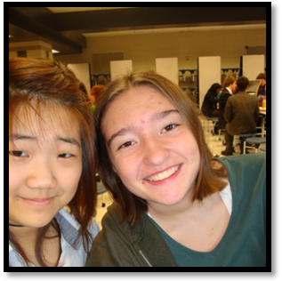
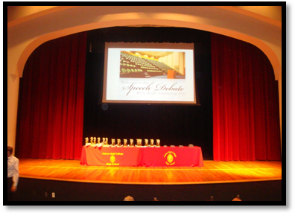
Figure 1: From Left to Right: Brian, Sophia, Nik, and Fiona
Figure 2: Fiona and Sophia
Figure 1: The State Competition's award ceremony

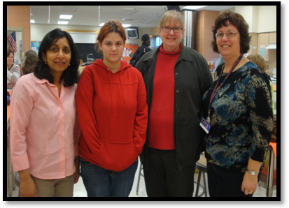
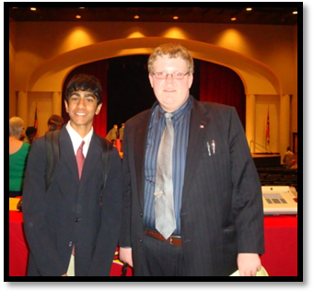
Figure 2: From Left to Right: Mrs. Khanna, Alyson, Mrs. Shouse, Mrs. Mandile
Figure 3: Brian and Nik at the State Competition's award ceremony
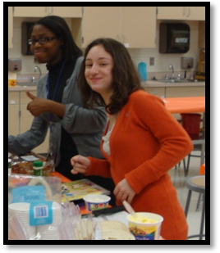

Figure 4: Dara and Elena after the last round of the tournament

2010-2011:
(Yet to be posted)
Reservoir
Speech and Debate Team

Speech Debate Dramatic Performance

Official Website

BY: Brian Shouse and Nik Khanna

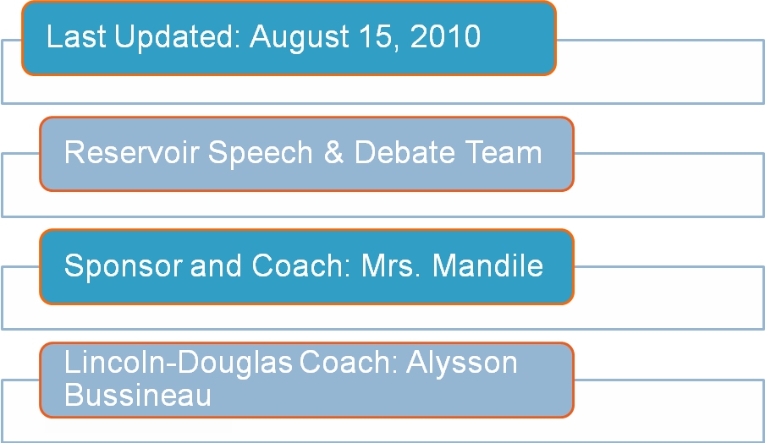
(Go to homepage)
WHY SHOULD I JOIN DEBATE?
(Works Cited)

